Renju lesson on January 25, 2001

Hello all! Welcome to Online Renju Class. We will continue learning d8 opening today. We are about to study the most popular variants of d8 opening. There are two possible 8th moves – g8 and i8. In case of 8-g8, black uses positional style, whereas 8-i8 lets black develop quite active position. Lets take a look at g8 first. Then we will know which are the main ideas for positional development in that variant. It is not easy to say which move is better for white because the evaluation of the 8-i8 variant is changing every month.
Please tell me the best 9th move. Move 9-g6 is the best. Now I ask you more difficult question. Why is g6 the best? Why is g6 better than g9? By the way, it is not very easy to explain why g6 is the best. Even in high level tournaments several players use g9 instead of g6. Move g9 looks good, it creates two black pairs, and at the same time white cannot attack either. The problem of g9 is – despite the temporary activity, black does not have enough material to win with direct development in one area, and it would be also too difficult to go back to positional style and control the whole board structures. It is much better to create only one pair, and at the same time keep the control over all structures on the board. Those who were present in class last week remember the similar thinking method. Remember, we discussed the choice of making either 3 pairs of its own, or one pair + block one opponent’s pair. And we made the conclusion that the control is more important than many lines. The choice of many lines can be more valuable than positional control in case when after that there is sure VCT.
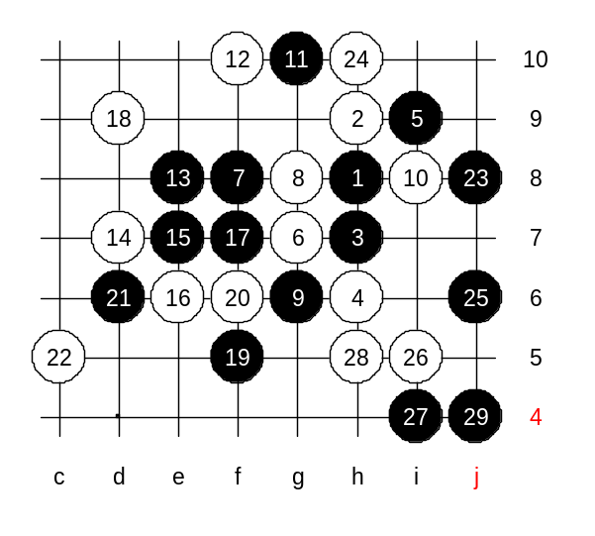
Indeed, g9 also blocks the white line, so it kind of looks like a defensive move as well, but if you take a close look then you see that white will have promising structures below. Move 9-g6 begins with positional control and ends with almost winning developments. Lets take a look. 10-i8 – a natural white move. After 11-g10 black has completed the positional control setup. Now, black has free way to develop towards almost any direction. Please choose the white move that you think is the best. It is quite obvious that white has to choose between f7, f9, f10 or h10. OK, lets try f10. The following black moves are just an improvisation and do not consider them as absolutely the best moves. I am sure even better developments can be found. You can choose the white moves here. Black is preparing the attack so that it would be possible to attack on either lower or upper side depending on white’s defense.
It looks like black is so strong by the 25th move. No matter how white defends now, black will win soon. Now you saw how black attacked using positional style. There is no need to continue this diagram. Black win is very close already.
If white had played k7 instead of h10 then black would develop winning attack with j10.

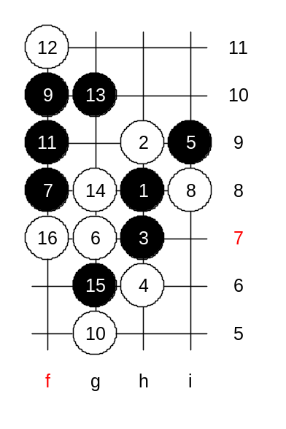
Lets try another 8th move now. Can you tell me all possible 9th moves here? Yes, you have shown all the best 9th moves – f10, g10, g9, j7. Move f10 is the most popular and probably the strongest. First we will learn some gambling variants where white plays actively and hopes that black fails the attack. Move 10-g5 is a famous trap. Lets try it. Does anyone of you know the black win?
After the 13th move black control all white structures, so white cannot attack and has to defend instead.
This is the advanced level homework. Please find the black win.

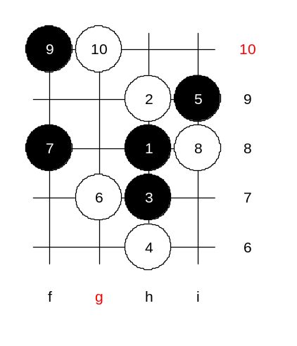
This is the medium level homework. Please find the black win.

